Bongman Non-wood Forest Product Management and Marketing Plan
KHAR GEWOG: PEMA GATSHEL
PLAN PERIOD: Sept 2021 – August 2026
First Revision

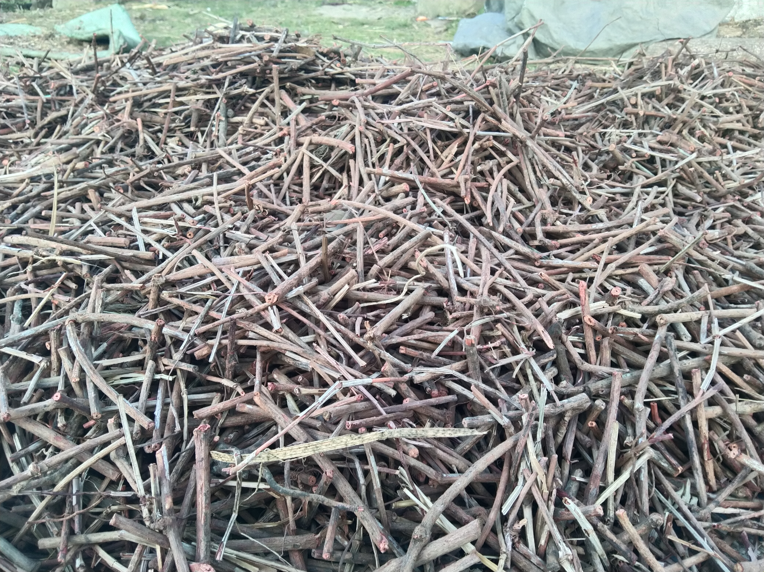
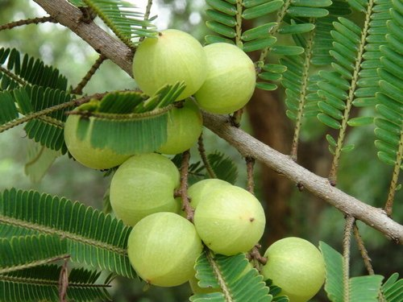
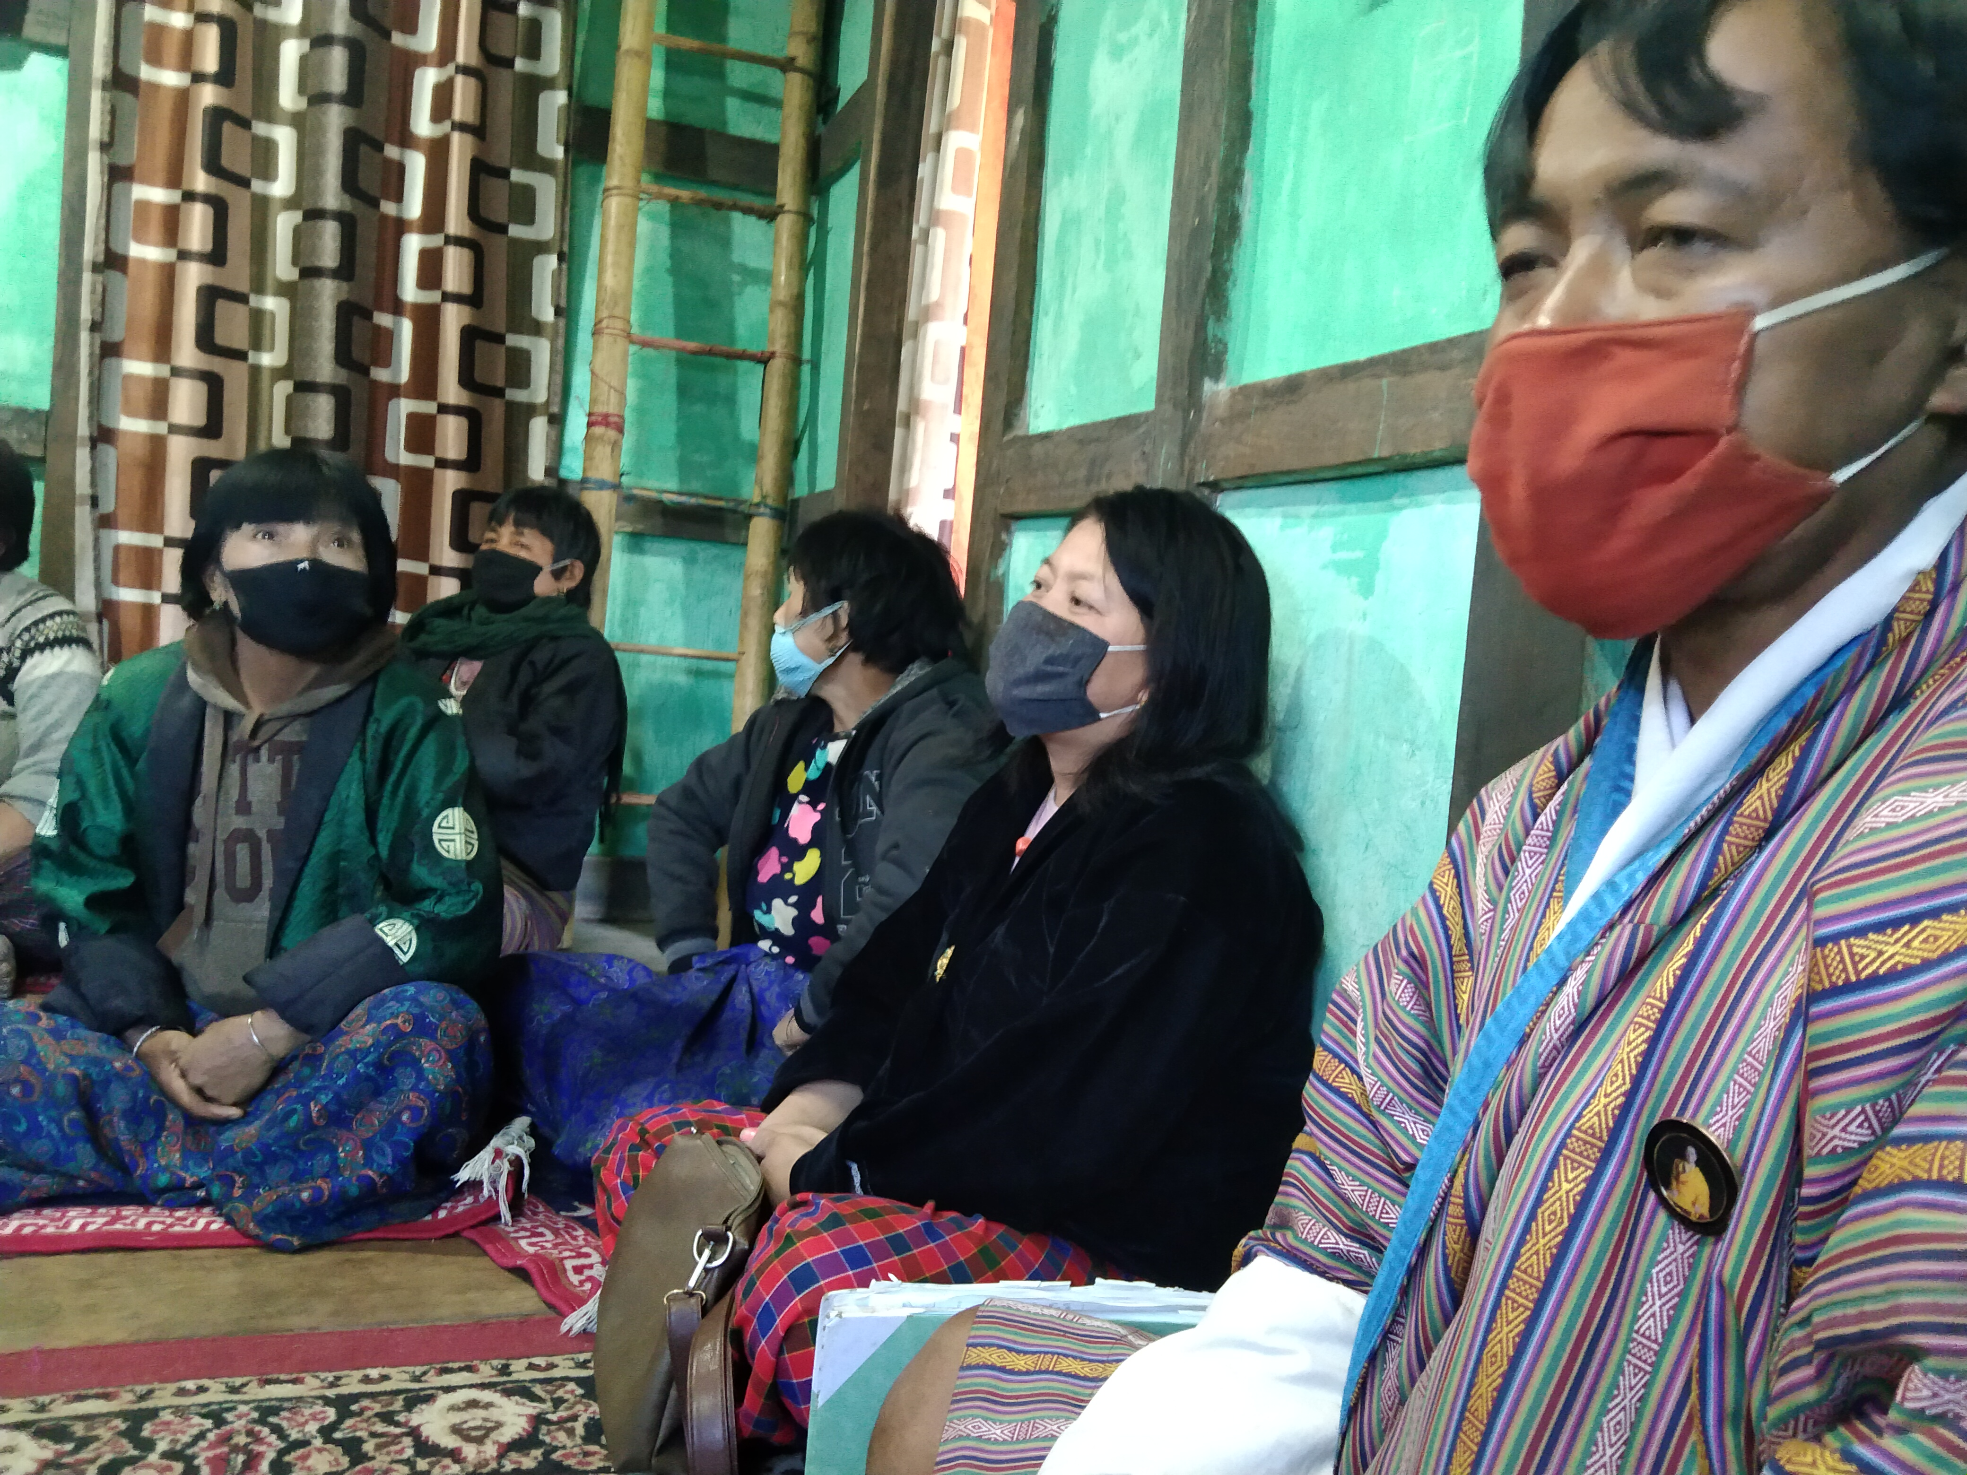
Table of Contents

PART I: NWFPS MANAGEMENT AND MARKETING PLAN 3
1. Introduction 3
2. The objectives of the management plan 4
3. Description of Non wood Forest Products(NWFP) 4
3.1 Rubia cordifolia (Tshangla Kha: Laniru) 4
Uses 5
3.2 Plectocomia Himalayacalmus (Patsha) 5
Uses 6
3.3 Emblica officinalis (Amla) 6
Uses 6
3.4 Bambusa nutans (Leshing) 7
Uses 7
3.5 Dendrocalamus hamiltonii (Soo) 8
Uses 8
4. Map of the NWFPs collection area. 11
4.1 Labar Chithuen NWFP collection area on google map 11
5. Marketing and sales plan 12
6. Marketing arrangements 12
7. Benefits to the members 13
8. Benefits to the group 13
PART II: BY-LAWS-GROUP REGULATIONS AND NORMS 14
9. Procedures for new membership 14
10. Procedures for leaving the membership 14
11. Responsibilities and rights of members 14
12. Executive committee and their responsibilities 14
12.1 Responsibilities of Chairman 14
12.2 Responsibilities of Secretary 15
12.3 Roles and Responsibilities of Treasurer 15
13. Tenure and benefits for executive committee 15

14. Community Development Fund and utilization of fund 16
15. Conflict resolution 16
16. Offences and Penalties 16
17. Meetings 17
18. Amendment of the NWFP By-laws 17
19. Member list 18

GLOSSARY AND ABBREVIATIONS
CDF Community Development Fund
CFO Chief Forest Officer
SFED Social Forestry and Extension Division
SRFL State Reserved Forest Land
DoFPS Department of Forests and Park Services
DT Dzongkhag Tshogdue
GRO Gewog Range Officer
HHs Households
NWFPs Non-Wood Forest Products
ToR Terms of Reference

PART I: NWFPS MANAGEMENT AND MARKETING PLAN

Introduction
Bongman village is located under Khar gewog. It lies at an altitude of about 1400 meters to 1800 meters above the sea level. It is about 20 kilometers away from Denchi, Dzongkhag Administration and about 30 kilometers from the Gewog center. The village has farm road and have access to all the basic amenities such as Renewable Natural Resources services, health and education. There are 18 households in the village. However, only 13 households have registered to continue as Non-wood Forest Product Management and Marketing group.
During the first plan period the group planned to collect and market NWFP products such as Plectocomia Himalayana (Patsha), Rubia cordifolia(Laniroo) and Thysanalaena latifolia(Tsakusha). However, they received demand only for Rubia cordifolia and have not collected other species much to generate income. As the market for NWFPs are not foreseeable, the group unanimously agreed to continue management and marketing of these earlier listed NWFPs and also want to include bamboo species (Dendrocalamus hamiltonii and Bambusa nutans in this plan period. Bamboo species are included as there is a potential for sale of shoots and matured culms on demand basis. Also through proper management of bamboos enterprise related to it can be established in the future. Bamboo grows on peripheral of their registered land and in State Reserved Forest Land. Therefore, the prescribed management plan will serve them as guidelines for sustainable management and utilization of resources and to earn income.
The Management plan consist of three parts: The part I which consist of descriptions of those important species, harvesting prescriptions, maps of NWFPs harvesting areas; Part II consist of marketing plan and benefits sharing and finally the Part III which consist of By-laws of the management plan. The By-law describes the roles and responsibility of executive committee and members, conflict resolution and penalties.
The term of management plan is for 5 years and will be effective from September 2021 to August 2026. During the period, the members will have right to collect mentioned NWFPs as per the harvesting guidelines prescribed in the plan and ensuring sustainable collection of resources.

2. The objectives of the management plan
- Protection and sustainable management of resources following the prescribed management plans.
- Income generation through sale of Non-Wood Forest Products.
- Ensure equal right over the resources collection and marketing.

3. Description of Non wood Forest Products (NWFP)

From diverse NWFPs species found in the area indentified, five will be collected at commercial scale. These are; 1) Rubia cordifolia 2) Emblica officianalis 3) Plectocomia himalayana 4) Dendrocalamus hamiltonii and 5) Bambusa nutans. The description and traditional use of each species are elaborated here under.

3.1 A brief description on Rubia cordifolia (Tshangla Kha: Laniru)
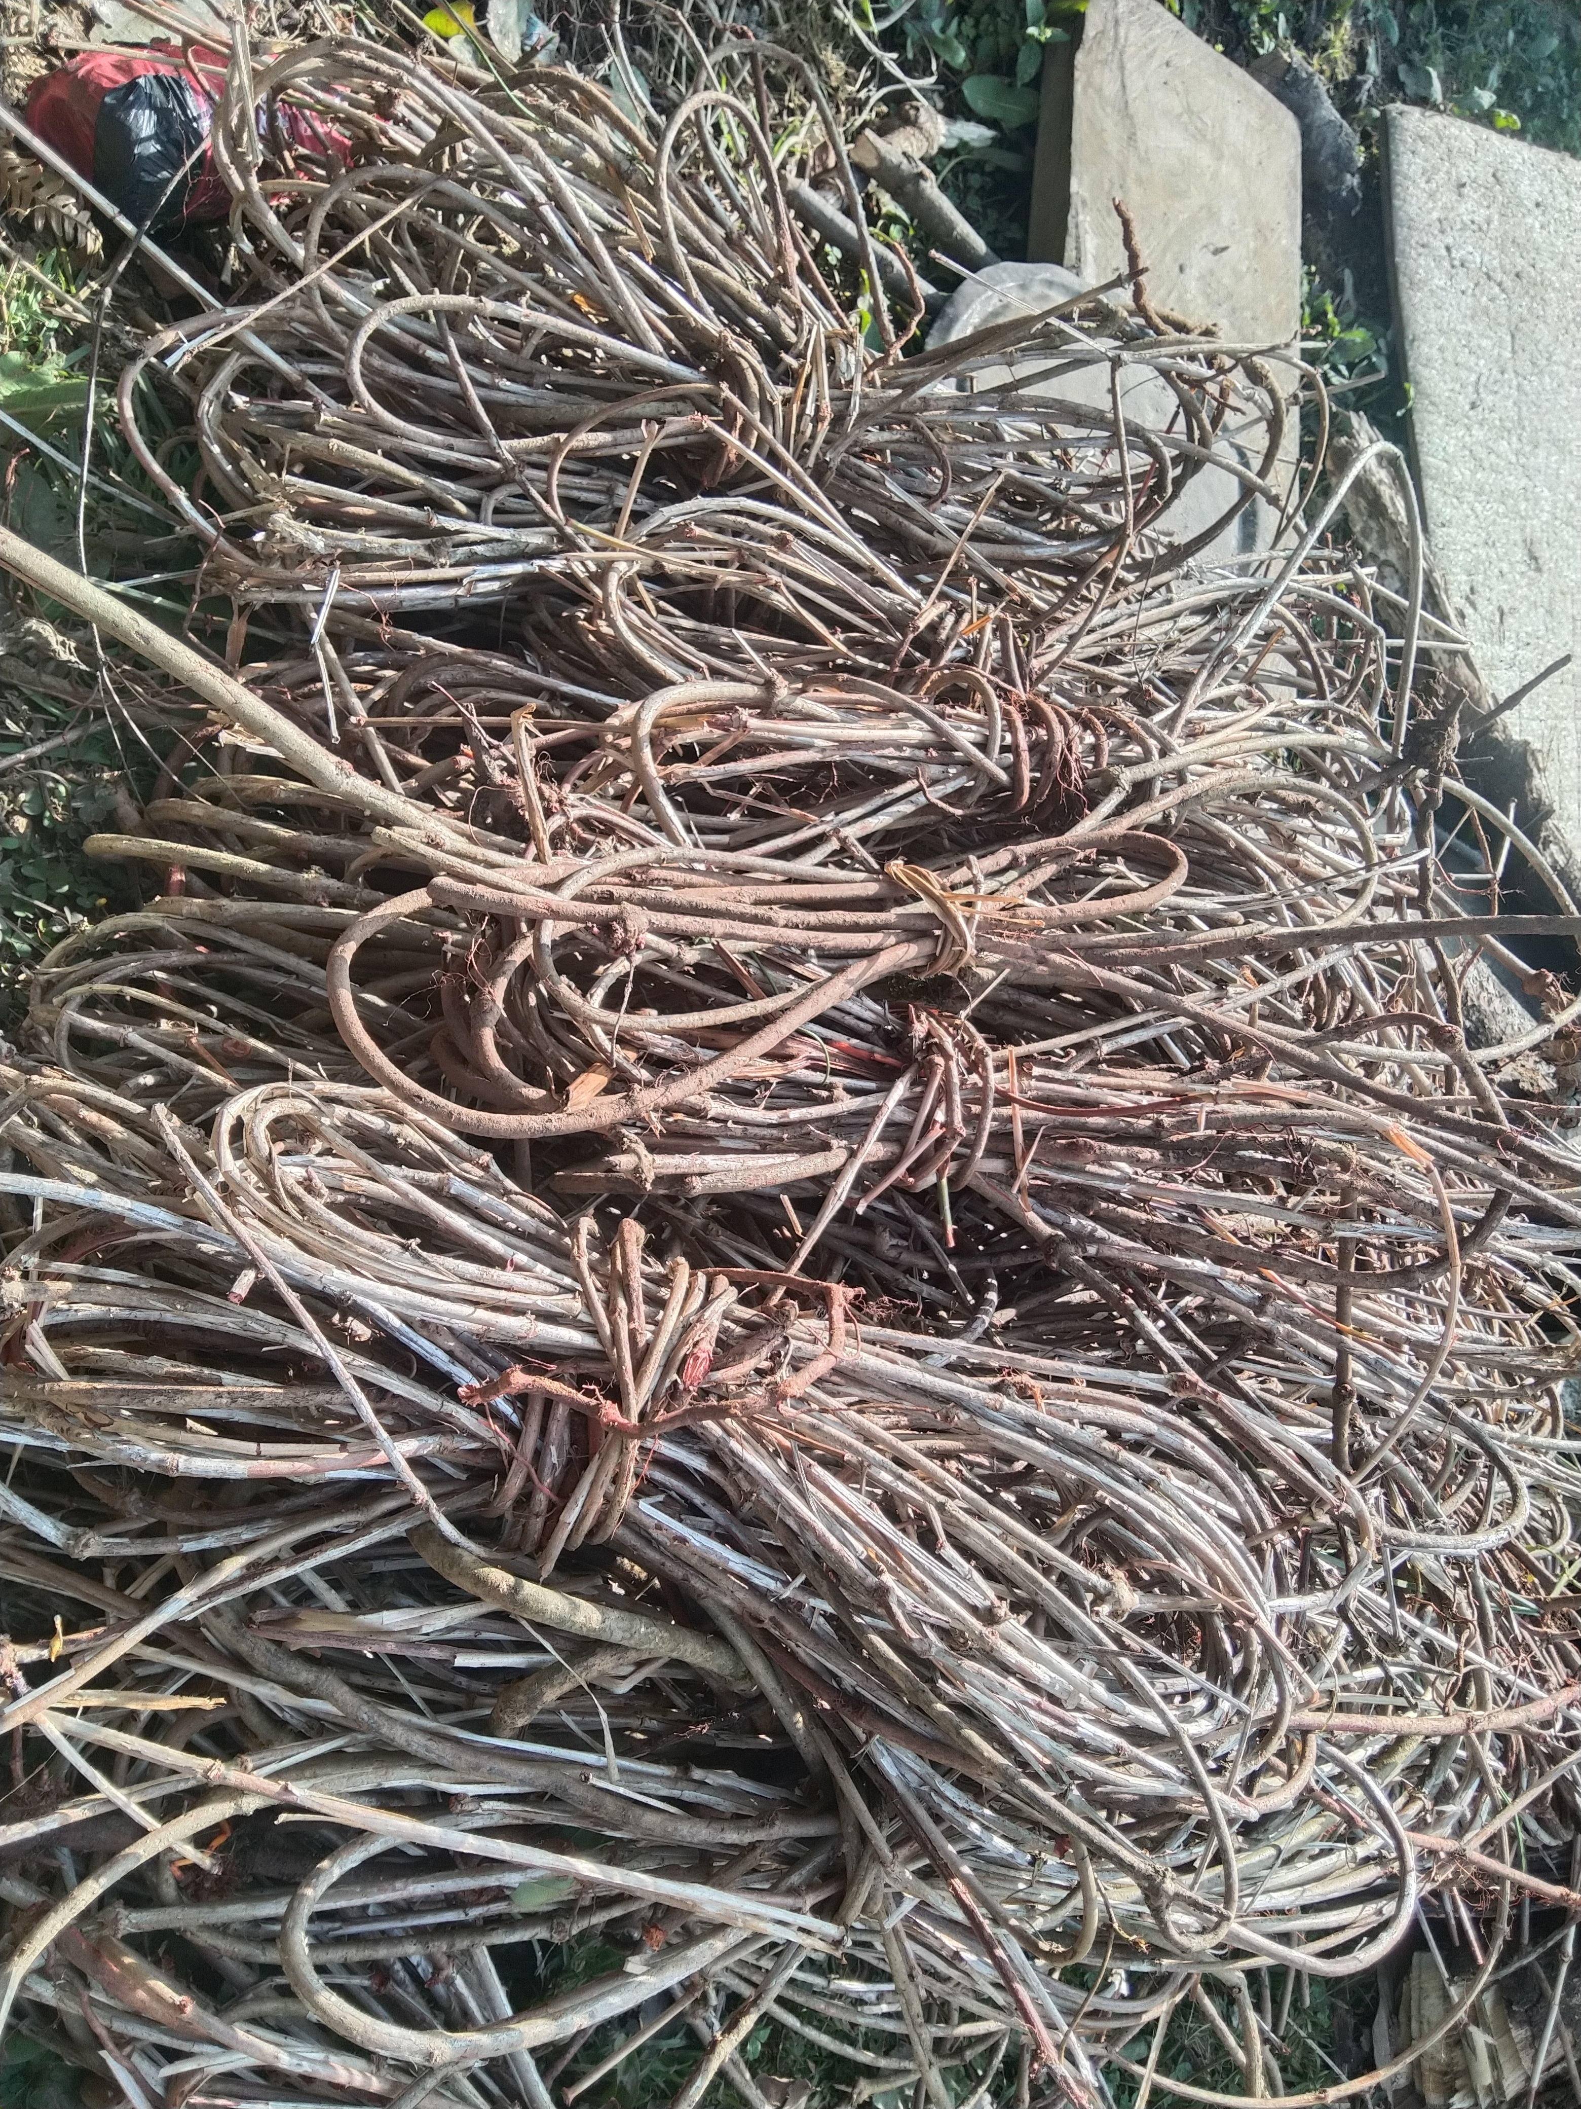

Figure 1: Rubia cordifolia collected from wild.

Rubia cordifolia is climbing or creeping perennial herb with stem up to 10 cm long, with woody, long, cylindrical, flexuous roots with thin red bark; stem branched, with long internodes.
The species has wide ecological adaptability. It is found in forest edges and clearing, shrub vegetation and dune forest. In the village, the species was found distributed throughout the villages thereby making easy and accessible for farmers to harvest. The roots and stem are harvested exclusively from the wild and from their private land by the farmers and exported as one of the main source of income for their livelihood.

Uses
The species is dye-producing plant and primarily harvested for processing dyes. The species is also known for medicinal values. It is used for treating wounds or cuts to stop bleeding as an antiseptic. The roots are used to as an emetic in case of stomach problems, to treat inflammation of the mammary glands in cattle and to cure itchy skin in human.

3.2 A brief description on Plectocomia himalayana (Patsha)
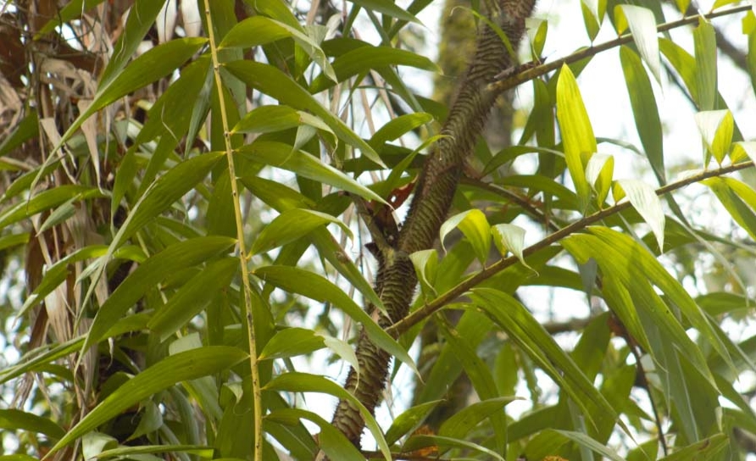

Plectocomia Himalayana is a spiny, evergreen, climbing palm producing cluster of stems that can climb high in to surrounding trees. In Bhutan, the plant is harvested from the forest for local use such as food, source of material for handicrafts and ropes etc. The plan is found in certain location of village. The species is usually found in broad-leaved hill forest, in degraded or disturbed areas.

Uses
It is used for manufacturing of handicraft and shoots/stem is consumed as vegetable which is bitter in taste. However, many Bhutanese love having its soup. The species is used as a raw material for making rope, or split in to strips for tying fences and for making rough basket. It can be another source of income for the farmers through sale of its shoot as vegetable.

3.3 A brief description on Emblica officinalis (Amla)


Emblica officinalis, commonly known as amla and locally known as Chur goen tsay, are small, round berries with light green skin. The skin is tough, yet thin flesh that is juicy with both bitter and sour taste. The fruit trees are found nearby Bongman village, Dungman ma and Numzor area.

Uses
The fruits are considered to possess high medicinal value, which enhance digestion, treat constipation, reduce fever and cough, strengthen heart, benefits eyes, stimulates hair growth and many other health benefits. The fruit are said to be rich in vitamin c. Though, it can be prepared as pickles and other recipes, the local people only consumed as fruits. Therefore, the pickles production and sale of its product is another added scope for farmers for income generation and employment creation for their better livelihood.

3.4 A brief description on Bambusa nutans (Leshing)
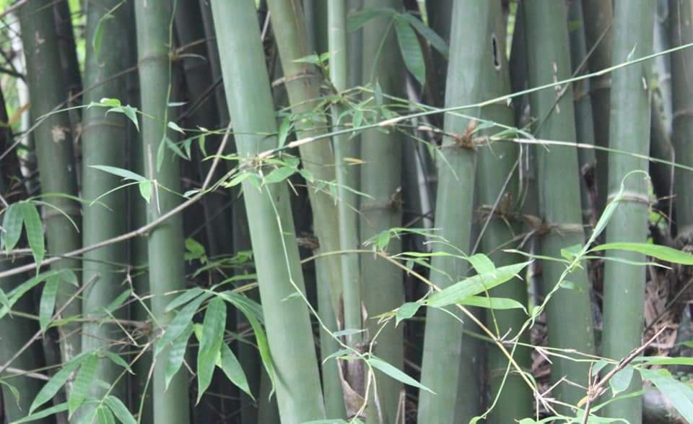
The bamboo is clump forming bamboo species that attain the height of about 23 meters and diameter of about 10 cm. The culms are straight having upraised nodes with small branches and leaves. Culms are strongly cupped with deciduous blade. Ligules of culms sheath are about 1-2 mm and margins are finely serrated. Leaf sheath have few tall bristles with smaller auricles. Ligules are short and are without hairs. The species is found growing in certain pocket of Bongman village.

Uses
Due to its straight and strong culm, the farmers use the culms mainly as fencing material, construction of watch tower for guarding the crops and for scaffolding. Archery enthusiasts also extract traditional bow from it. However, due to constructional activities taking place in Denchi, the demand for the culms is always on rise. Therefore, farmers consider the species as promising source of income to ensure sustainable management and harvesting in future.

3.5 A brief description on Dendrocalamus hamiltonii (Soo)
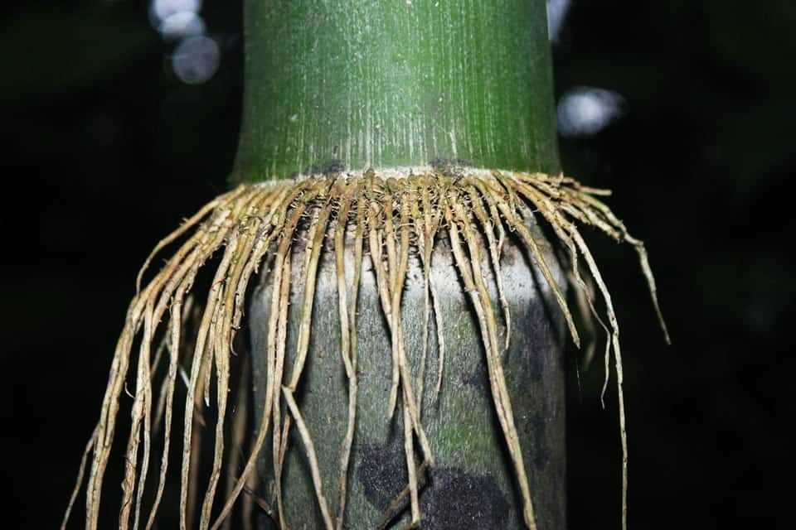

Dendrocalamus hamiltonii is widely found growing in the wild. It is usually distinguished by presence of brown/ white fur. The culm has thin wall and are flexible. The branches have curving branch lets. Culm sheath auricles are without bristles and are dentate at the edges. The leaf sheath has tall rounded ligules without auricles and bristles. White hairs are seen on leaf sheath. The species is found in Mesamri and in Laybayri area.

Uses
The shoots of the particular bamboo species is collected and consumed as vegetable. Also in some part of Bhutan (southern) they prepare pickles preparation out of it. The bamboo species is also suitable for production of bamboo handicrafts due longer internodes and flexibility. This is one of the potential bamboo species suitable for larger scale plantation for production of commercial edible shoot. Therefore, the management of this bamboo species has added benefit to the group and individuals for income generation.

Table 1: Brief description of NWFPs for commercial harvesting
NWFP name | Name of Collection area | Parts harvested | Use purpose (traditional and others) | Harvesting season (months) | Estimated annual harvesting limit
Rubia cordifolia  (Laniru) | Omshagang, Manidang, Dungkhar, Labayri, Mesamri | Mainly the stem | Dyes | December – February | 1500 Kgs in a year
Thysanolaena latifolium | Gotkhar, Bongman area. | Inflorescence | Brooms | November to March | 50 bundles
Plectocomia Himalayana (Patsha) | Manjuzor | Shoot and matured Stem | Vegetables and handicraft | May to September | 100 Kg
Emblica officinalis | Bongman area, Dungman ma, Numzor | Fruit | Pickle making and eaten as a fruit | October to March | 50 Kg
Bambusa nutans (Leeshing) | Numzor, Bongman area,  Nakpoladrang toed | Culm | Scaffolding and traditional bow | November to March | 100 culms
Dendrocalamus hamiltonii (Sok) | Mesamri, Laybayri | Shoot and culm | Bamboo shoot processing and handicrafts | July to August | 50 Shoots  100 culms for handicrafts

Table 2: Harvesting prescriptions for sustainable NWFP harvesting
NWFP species | Harvesting prescriptions for sustainable harvesting
Rubia cordifolia (Laniru) | - Cut the stem about 2 inches above the ground.  - Retain 10% of total population in the particular collection site for regeneration and seeding.  - Uprooting of whole plant is restricted.
Thysanolaena latifolia  (Tsakusha) | - Cut the foliage, 15 cm from the ground after harvesting inflorescence.  - Do not damage the rhizomes in order to allow natural regeneration.  - Do not burn rhizome to stimulate regeneration.
Plectocomia Himalayana (Patsha) | - Cut the shoot for vegetable only for cane which are not climbing on trees.  - About 10% of total population in particular area will be maintained to prevent depletion of resources.  - Not all the stand will be harvested. About 20% of population should be maintained.  - Cut only matured canes which are more than 10 meters for handicrafts.
Emblica officinalis | - Harvest only ripe fruit.  - Maintain about 20% of its total for wild animal and seed dispersal.  - Do not break or cut the branches and inflict damages.
Bambusa nutans (Leeshing) | - No harvesting of culm during shooting and in summer season  - Shall be harvested for scaffolding only upon demand from customers.  - Seek technical support from trained forestry official on harvesting techniques and management of Bamboo.  - Retain young bamboos.
Dendrocalamus hamiltonii (Sok) | - Maintain 50% of total shoots for regeneration in particular clump.  - Harvesting to be specific within prescribed collection period.  - Seek technical support from trained forestry official on harvesting techniques and management of Bamboo.

4. Map of the NWFPs collection area.

4.1 Labar Chithuen NWFP collection area on Google map
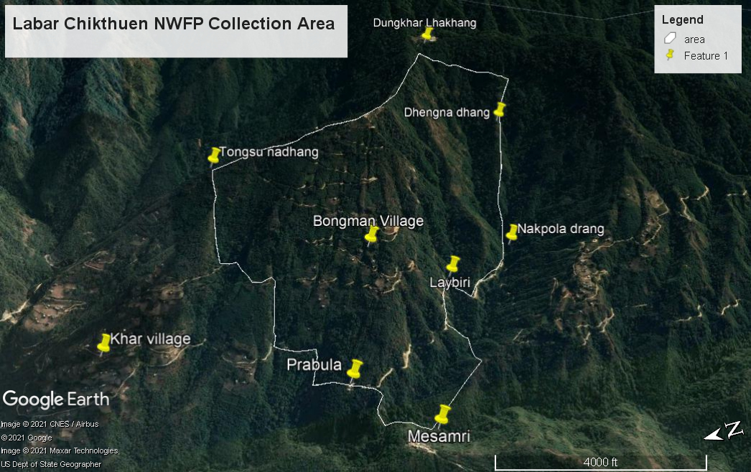

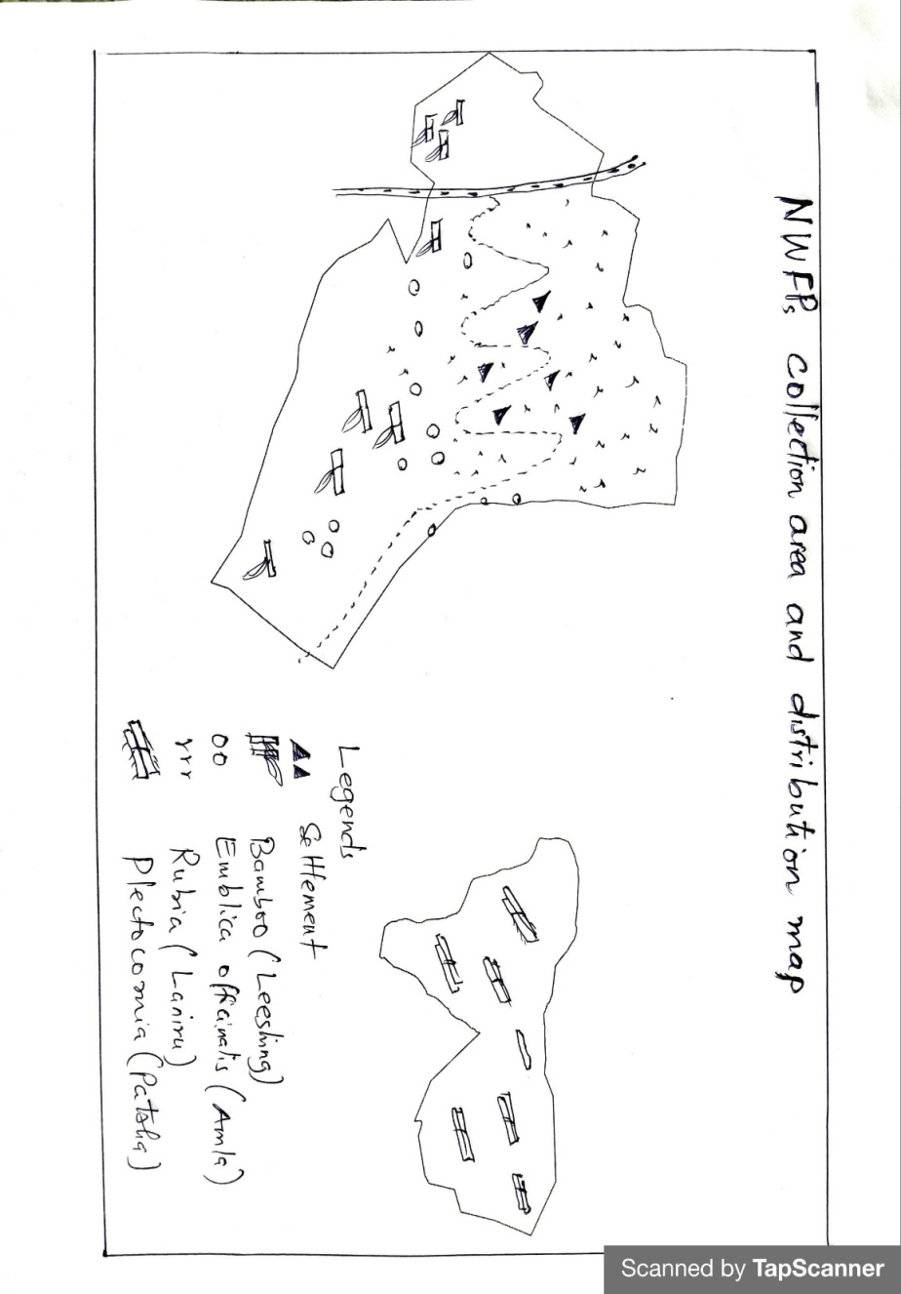

4.2 Sketch map of the NWFP collection area

5. Marketing and sales plan
Table 3: Marketing and sales plan of NWFPs
NWFP name | Potential market | Estimated quantity for sale per season | Expected price per unit (Nu) | Total  (Nu.)
Rubia cordifoia (Laniru) | Local trader and Licensed Exporter | 1500 Kgs | 60 | 90000
(Thysanolaena latifolia (Tsakusha) | Local trader, local market, and vegetable vendors | 50 bundles | 40 | 2500
Plectocomia Himalayana (Patsha) | Local trader, local market, and vegetable vendors | 50 Kg | 100 | 5000
Emblica officinalis | Local trader, local market, and vegetable vendors | 50 Kgs | 100 | 5000
Bambusa nutans (Leeshing) | Contractor, Archers | 100 culm  10 pairs of bow | 100  1000 | 10,000  10,000
Dendrocalamus hamiltonii (Sok) | local market, and vegetable vendors | 50 Kgs of shoot | 80 | 4,000
Total |  |  |  | Nu.126,500.00

6. Marketing arrangements
The members will collect the NWFPs individually, dry them and store properly. The executive committee members will collect the NWFPs product to the auction yard and inform to the concern forestry official/DAMC. The concern forestry official/DAMC will then organize NWFPs auction to various NWFPs traders including Indian markets. The auction will be organized in the presence of Chairman from the respective NWFPs group representing the members.
The executive members may deduct the expenditure such as transportation, necessary deduction and compensation prior to the payment to the individual member. The sharing of income to the individual group member will be done based on the quantity of NWPs collected by the respective members after deduction of all necessary expenditure.

7. Benefits to the members
The income earned from sale of NWFPs after necessary deduction will be rights of the individual member. Therefore, it act as source of income to meet their basic necessities like buying of households essentials such as salt, rice, sugar and oil. Additionally, the income earned from the sale of NWFP affords parents to meet expenses of school going children.

8. Benefits to the group
Through group formation, all individual members have equal opportunities and access to resources. The group can collect the various NWFP products legally based on sustainably harvesting methods prescribed in the management plan. Through this, the group can also support the welfare of individual member, thereby enhancing socioeconomic development in the group. Most importantly, being the part of a group helps the community in fostering the community bonds for betterment of the society and rural livelihood.

PART II: BY-LAWS-GROUP REGULATIONS AND NORMS
Name of NWFP Group: Bongman Non wood Forest Product Management and Marketing Group
Total Members: 13 Households

9. Procedures for new membership
- Membership fee of Nu. 50/- shall be collected annually by treasurer
- No new membership will be entertained.
- The collected fee and fund shall be deposited in the joint account operated in name of the group and shall be termed as a Community Development Fund.

10. Procedures for leaving the membership
- Any members withdrawing from the group without interest will be allowed without any benefits from the group.
- Member withdrawing from the group due to old age without any children to continue or due to unavoidable circumstances/problems, he/she shall be entitled to get his/her share from joint account (CDF).

11. Responsibilities and rights of members
- The group members participating in management of NWFP will have equal rights and responsibilities for controlling, protection, management and harvesting in the identified collection areas.
- The individual members will have the equal rights to collect and harvest as per prescribed management plan.
- Every member of the group will have equal access to report to the committee members for violation of the management rules.
- The members should sell the collections only through the group and not individually.

12. Executive committee and their responsibilities

12.1 Responsibilities of Chairman
Name of Chairman: Mr. Tshedup (Contact #: 17833075)
- To chair all kinds of meeting related to NWFPs management and marketing.
- To resolves the disputes and conflict among the members.
- To enforce the fine and penalty to members and as well to outsider who violets by-laws.
- To explore market for the products
- Find buyers and finalize quality and quantity required.
- Fix date of collection and inform group member.
- Maintain contacts with traders, to arrange & coordinate marketing of NWFPs.

12.2 Responsibilities of Secretary
Name of Secretary: Mr. Kin Chojay (Contact #: 17979927)
- Provide assistance to the Chairman.
- Officiate as Chairperson during his absence.
- Maintain records of the activities implemented, and also minutes of meeting.
- Responsible for writing official correspondence.
- Compile the progress report and submit to the Gewog Range Officer for further submission to Divisional Forest Office.
- Maintain record of NWFPs quantity collected from each member and payment made.

12.3 Roles and Responsibilities of Treasurer
Name of Treasurer: Mr. Karma Wangdi (Contact #: 77265652)
- To maintain detail financial record and present the details funds to Committee and the group members when necessary.
- Officiate as Chairperson or Secretary in their absence.
- Maintain the cash transaction record, submit expenditure and cash balance report to Chairman and present it to the members during meetings.
- Facilitate collection of membership fee from the group members.
- Deposit of cash collected from members.
- Collect sale proceeds from the members.

13. Tenure and benefits for executive committee
- The tenure of service for the committee members is for 5 years.
- Anyone representing the NWFP group and attends meetings/important gatherings will be provided with transportation charges with recommendation and verification done by Gewog Range Officer. However, to claim travel expenses, the individual shall produce following documents dually verified by the Gewog Range Officer.
- Vehicle number and vehicle type
- Name and CID number of Driver
- Total expenditure incurred/Bills/ cash memo
- Executive committee will be paid Nu.1000/- annually as service charge with prior discussion and notification to members.

14. Community Development Fund and utilization of fund
- The source of community development fund will be from sale of NWFPs products, membership fees and fine and penalties.
- The bank account will be operated by Chairman, Secretary and Treasurer, and they are signatory authority of the Bank Account. All sale and expenses done by the Chairman, Secretary and Treasurer should be in the notice of members.
- All expenditure incurred the group activity will be born from the joint Account.
- Technical support and guidance will be sought from the concerned GRO.
- The individual members will deposit 10% of the total amount earned from the sale of any NWFP products irrespective of the price fluctuation and shall be deposited in common CDF Bank.

15. Conflict resolution
The issues/conflict related to NWFP will be resolved by NWFP executive committee based on their capacities. The unsolved conflict will be forwarded to Gewog Administration through Chairman. Unresolved issues will be forwarded to Divisional Forest Office for necessary action.

16. Offences and Penalties
Sl No | Activity | Procedures | Penalty for defaulter
1 | Meetings/ Labour contribution | The secretary of the group will inform one day ahead to the members through Wee chat or voice call. | 1st absentee: Nu. 200/-
 |  |  | 2nd absentee: Nu.200/-
 |  |  | 3rd absentee: Expelled from the membership upon unanimous decision of the members.
2 | Collection of NWFP before or after time period fixed | Dec - Feb | Product will be seized and will be fined Nu.2000/- per occasion.
3 | Not abiding to number of collector specified per Household in the plan | One/HH | Product will be seized from one of the individual and will be fined Nu.2000/- per head count.
4 | Collection site will be within designated boundary. No land owner shall have right to claim the ownership of NWFPs. | Registered land and State Reserved Forest Land. | If private land owner restrict the collection of NWFP claiming the ownership, the owner shall pay the fine of Nu.215/- to all the registered members.
5 | Non-members collecting the NWFP in their NWFP area. | No Non-members will be permitted to collect the NWFPs. | The products will be seized and will be fined as per the FNCRR-2017.
6 | Deployment of Non-member for NWFP collection as a substitute. | Member should collect and no subsitute allowed | The product shall be seized and fined Nu.2000/- per head count.
7 | Sale of products without approval and notice of executive committee. | Sale of product only through open auction | The offender shall be terminated from membership permanently.

17. Meetings
The meeting will be conducted before and after collection of NWFPs. Also ad hoc meetings will be conducted as and when necessary.

18. Amendment of the NWFP By-laws
The by-laws will be amended based on the needs to resolve issues, problems and constraints in consultation with Gewog Range Officer and approval from Divisional Forest Office. It will be done after seeking approval from Chief Forestry Officer, Pema Gatshel.

19. Member list
